PushWhacker for Ableton Push 2

One page summary

PushWhacker is a Windows 10 application to use an Ableton Push within any music software.

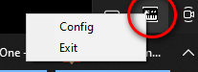Download and unzip to a folder anywhere on a Windows PC.

Run PushWhacker.exe. All you will see is a new icon in the tray that responds to a right click:

Use loopMIDi (<https://www.tobias-erichsen.de/software/loopmidi.html>) and create a virtual Midi port of any name. In the PushWhacker Config, in the “Output” tab, select that virtual Midi port as output and use it as input to your DAW or other software. You are now ready to use your Ableton Push 2 as input to any music software. The current configuration is displayed on the Push 2 screen.

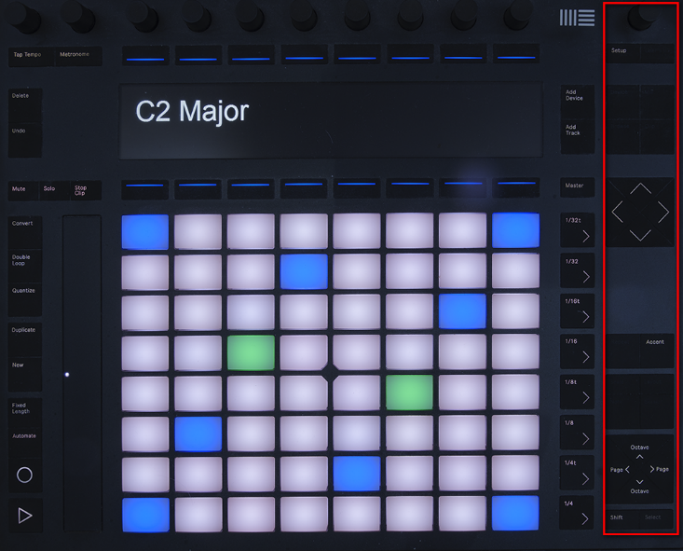The buttons and knobs on the right-hand side (outlined in red on picture) are used by PushWhacker or reserved for future use. All other buttons and knobs are available to be mapped within the DAW.

Pad pressure can send channel or polyphonic aftertouch or can be used to boost Modulation.

Controls on the right allow selection of a wide range of scales, all 12 key roots, and any octave.

The Page <> buttons allow selection between (currently) 8 layouts:

* **In key** (illustrated). Notes are arranged in fourths showing only the notes of the chosen scale.
* **Chromatic**. Notes are arranged in fourths showing all notes, highlighting those of the chosen scale.
* **In Key with KS**. The three left columns are used for chromatic key-switch notes not transposed or filtered by key, octave, or scale. KS range is C-1, C0 or C1 upwards.
* **Chromatic with KS**. As above for a Chromatic layout with key-switches.
* **Scaler**. A grid corresponding to the layout of chord pads in the Scaler (<https://www.scalerplugin.com/>) pad view.
* **Strummer**. A sensible layout for strumming AmpleSound (<https://www.amplesound.net/en/index.asp>) guitars.
* **Drums**. Four separate 16-note drum-pad grids compatible with most drum software.
* **Big Drums**. One 16-note drum-pad grid with 4 adjacent pads per note, suitable for flams etc.

The Key root note (in each octave is coloured blue. Middle C (or the nearest in-key note) is green.

A connected second foot pedal can be a switch CC (on-off control), a continuous foot controller (with a calibrated range), or a switch to raise any note played by a semitone (for in-key accidentals).

The “Accent” button toggles the strip control between Modulation and Pitch Bend.